**EXPERIMENT - 11**

**AIM OF THE EXPERIMENT:**

To set up and study square waveform, triangular waveform and sawtooth waveform generator using Op-Amp

**APPARATUS REQUIRED:**

PC loaded with multisim software

**THEORY:**

# Square wave oscillator

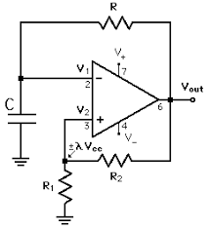The basic square wave oscillator is based on the charging and discharging of a capacitor. Op-amps inverting input is the capacitor voltage and the noninverting input is a portion of the output fed back through resistors and (refer figure 1). When the circuit is first turned on, the capacitor is uncharged, and thus the inverting input is at 0V. This makes the output a positive maximum, and the capacitor begins to charge towards voltage at *V*O through resistor R. When the capacitor voltage reaches a value equal to the feedback voltage (*Vf*) on the non-inverting input, the op-amp switches to the maximum negative state. At this point, the capacitor begins to discharge from +*Vf* towards –*Vf*. When the capacitor voltage reaches –*Vf*, the op-amp switches back to the maximum positive state. This action repeats and a square wave output voltage is obtained.

# Triangular-wave oscillator

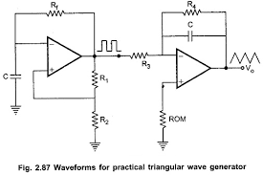This circuit (figure 2) uses two operational amplifiers. Op-amp A1 functions as a comparator and the op-amp A2 as an integrator. Comparator compares the voltage at point P continuously with respect to the voltage at the inverting input; which as at ground potential. When the voltage at P goes slightly below zero, the output of A1 will switch to negative saturation. Suppose the output of A1 is at positive saturation +*V*sat. Since this voltage is the input of the integrator, the output of A2 will be a negative going ramp. Thus, one end of the voltage divider R1-R2 is at +*V*sat and the other at the negative going ramp. At time *t* = *t*1, when the negative going ramp attains value of –*V*ramp the effective voltage at point P becomes slightly less than 0 V. This switches output of A1 from positive saturation to negative saturation level –*V*sat. During the time when the output of A1 is at –*V*sat, the output of A2 increases in positive direction. At the instant *t* = *t*2, the voltage at point P becomes just above 0 V, thereby switching the output of A1 from –*V*sat to +*V*sat.

### **Sawtooth-wave oscillator**

The difference between the triangular and sawtooth waveform is that the rise time of the triangular wave is always equal to its fall time while in sawtooth wave generator, rise time may be much higher than its fall time or vice versa. The triangular wave generator can be converted to a sawtooth wave generator by injecting a variable dc voltage into the noninverting terminal of the integrator. This can be done by using a potentiometer as shown in figure 3. When the wiper of the potentiometer is at the centre, the output will be a triangular wave since the duty cycle is 50%.

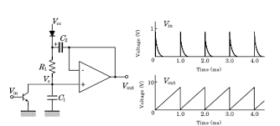

**Implementation:**

Square wave generator

Circuit Diagram

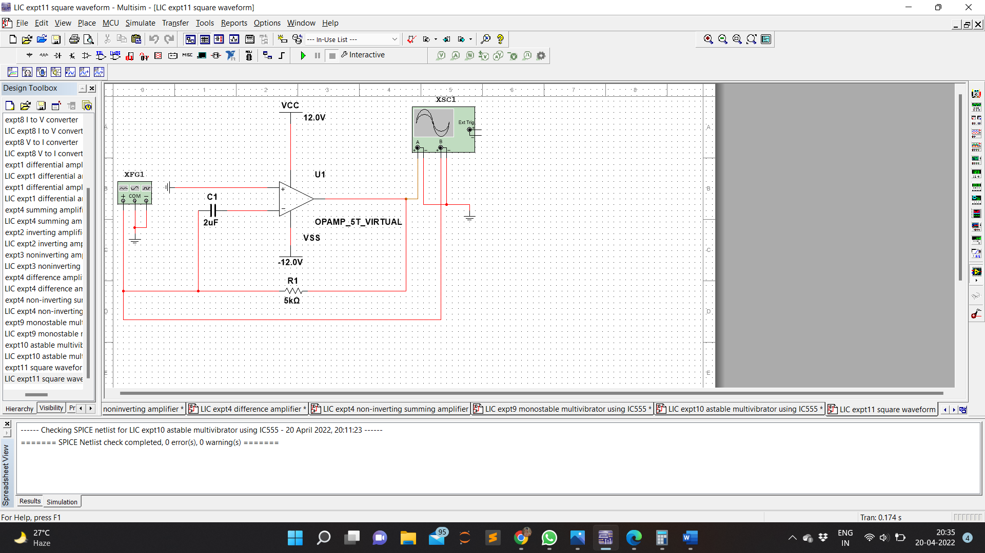

Waveform

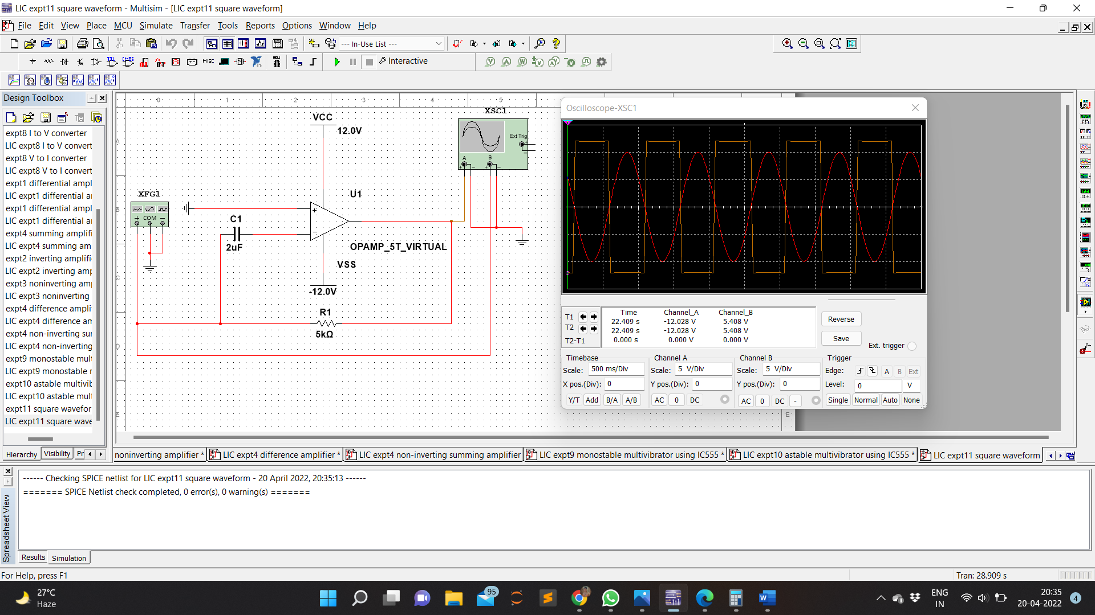

Triangular wave generator

Circuit Diagram

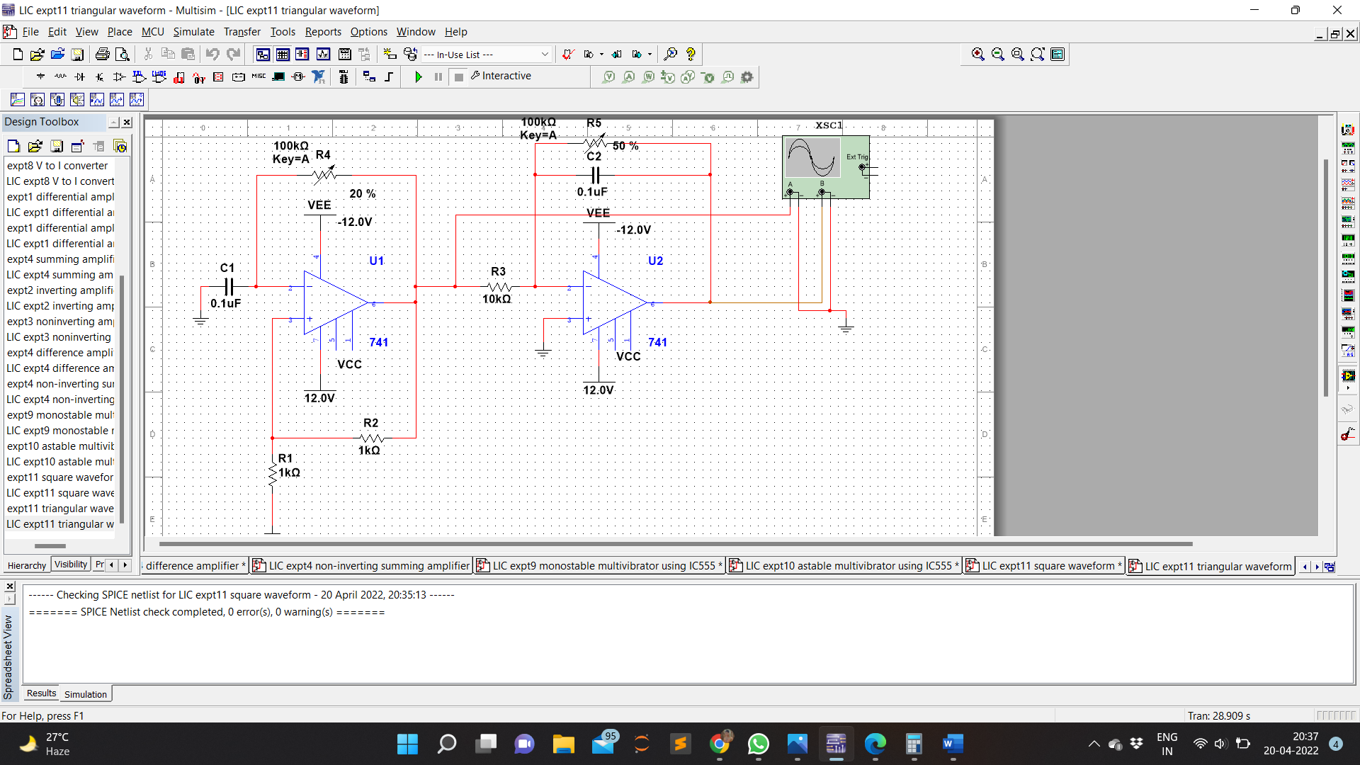

Waveform

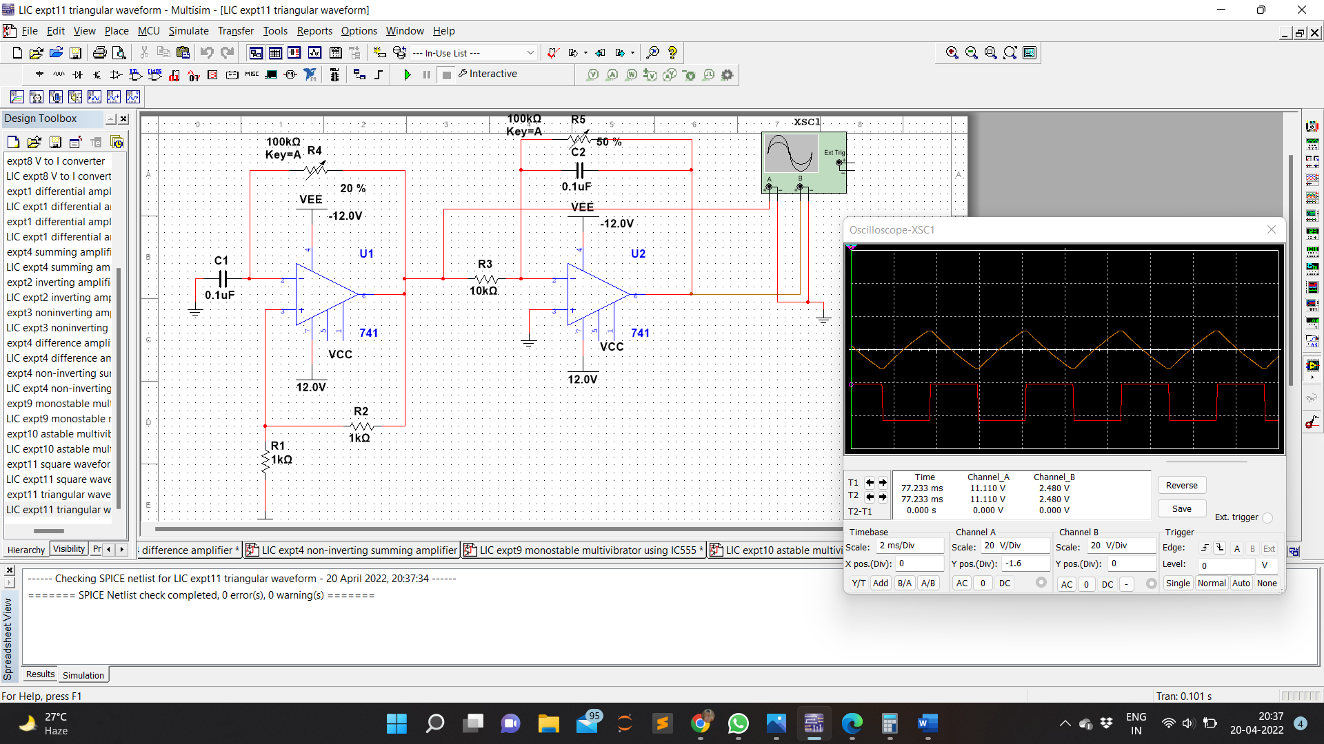

Sawtooth wave generator

Circuit Diagram

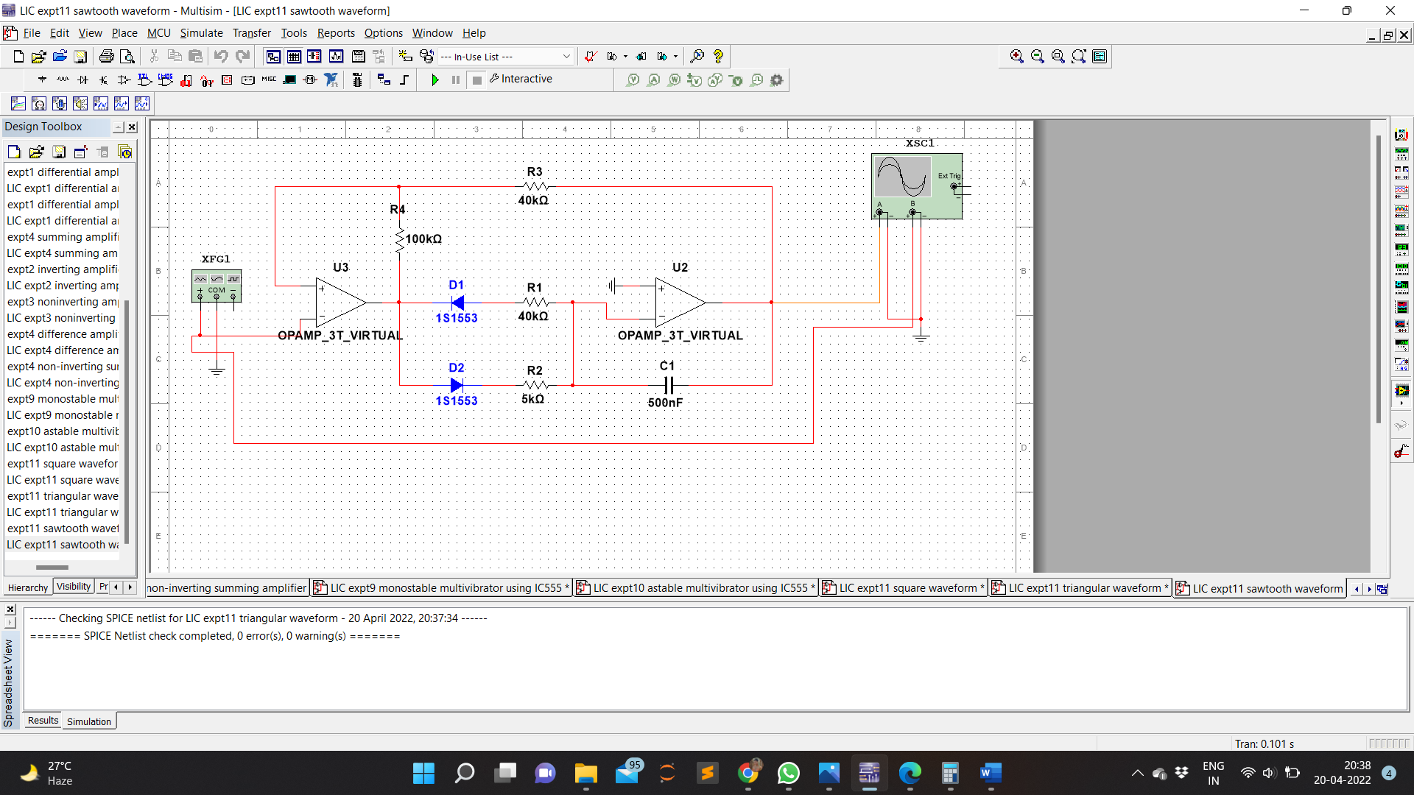

Waveform

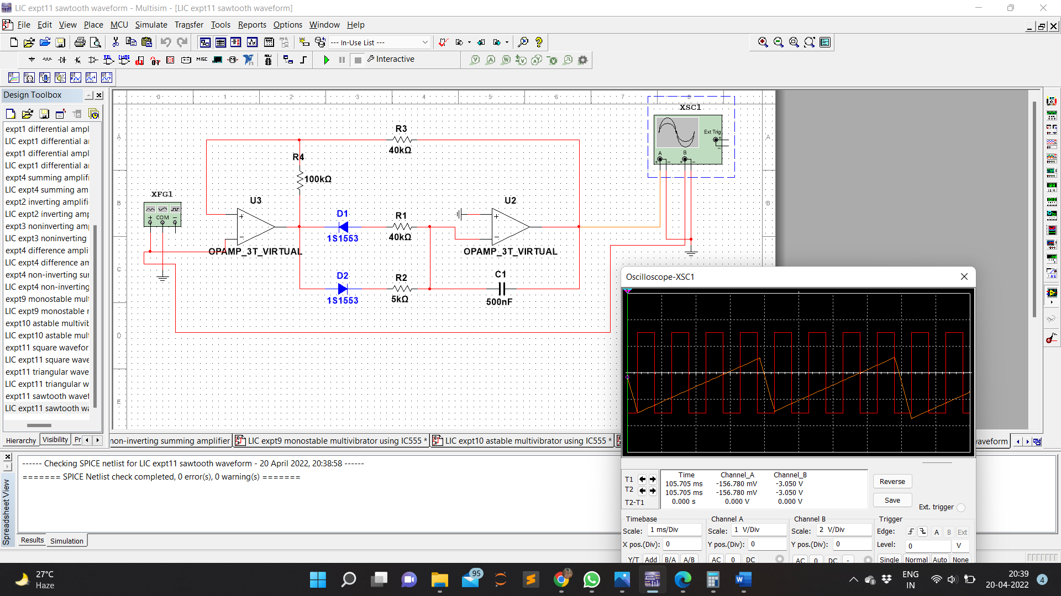

**RESULT:**

square waveform, triangular waveform and sawtooth waveform generator was designed , implanted and studied using Op-Amp in Multisim.